Rasch Model Detection of Cultural Bias in Preschool Testing of

South American and Hispanic American Children

Cecilia Vargas
College of Education
University of South Florid al St. Petersburg
140 7th Avenue South
St. Petersburg, Florida 33701

Faculty Advisor: William Steve Lang
Department of Educational Measurement and Research

The number of Hispanics in the con1inen1al United S1a1es is increasing dramatically. Shortly after 1he year 2000. Hispanics will be I he largest minority group in the United S1a1es according to government projections. Unfortunately, there has not been an appropriate increase in development and research of bilingual assessment ins1rumen1s. Bilingualism has been acknowledged to be a complex problem in psycho­ educational assessment for over half a century (Arsenian, 1937). Several studies have commented on the serious drawbacks of using standardized. commercially developed. English language assessment instruments for limited English proficient or bilingual children (Figueroa, 1983). These studies indicate the need for Spanish versions or translations of assessment instruments. and suggest that these 1ransla1ions undergo intensive comparative research. Mardell­ Czudnowski (1987) noted that when an American normed test (in this case the DIAL-R) is used with bilingual children results should be interpreted with extreme caution. It was further suggested that local norms based on the heterogeneous population are critical to the validity oi the test results.
This research design was intended to answer the following question: does each item on the Spanish translation of The Lollipop Test: A Diagnostic Screening Test of School Readiness-Revised produce the same relative logic ability and fit statistics for English and Spanish students as a measure of bias.

PROCEDURE
The Lollipop test was written by Alex Chew and translated into Spanish by Judy Schamber (1989). The test was administered to Hispanic American children in Pinellas and Hillsborough counties. Several preschools were approached to test these children. This allowed observation of testing practices in these schools concerning these children. Although many of these children's parents could not speak English the children appeared to have some bilingual ability simply from living in the United S1a1es. Consequently when giving the test the answers provided by the students were in Spanish and English. The Lollipop test allows for both answers. which is a bcneii1 to the child. Most teachers could not speak Spanish and were having trouble communicating with the children. and especially with the parents. In one serendipitous discovery, after administering the Lollipop test to several children and who scored highly on the test. I went into their cumulative file and found low scores on a

283

different standardized test they had been given. These students had not been tested fairly, because the test given to them previously was in English. The problem arises when these scores are used for placemen1 of children in classes grouped according to aptitude. These children may be severely hindered by being placed in a “low” class (Figueroa, 1983).
While obtaining parental authorization, one parent objected strongly to his little girl’s testing -- his biggest fear was the school would use these scores to place his child in a remedial class. He related that had happened to his older child, and he didn’t want that to be the case with his daughter. This man’s frustration was evident. Imagine yourself in a country where you can’t speak the language and your child is being tested and placed, perhaps unfairly, and the teachers can’t understand you or your child. Then one sees the importance of a test in the student’s native language.

Subjects

The subjects were 80 four and five year old preschoolers from public preschools and kindergartens in Georgia, Florida and Bolivia. The data from the United States was collected in the spring of both 1992 and 1993 by examiners trained in the administration of the test. For Hispanic children. the examiner spoke both English and Spanish. The South American data was collected in the winter of 1994. As is typical with bilingual children in the United States, many often spoke Spanish at home and English at school. The examiner informally asked the Hispanic children if Spanish was the language spoken at home and answered any questions regarding the testing permission for Spanish-speaking parents.

Instrument

La Prueba Lollipop (Chew, 1989) is an individually administered, criterion-referenced screening measure of school readiness consisting of the following four sub1ests: (1) Identification of Colors and Shapes; (2) Picture Description, Position, and Spatial Recognition; (3) Identification of Numbers and Counting; and (4) Identification of Letters and Writing. The test items are individually administered orally with a total score range of 0 to 69.

Statistical Analysis

Even though the original scoring instructions for the rest gives various For purposes of analysis, the test items were entered as single point, dichotomous data. The result was that all 58 separate items were included in the analysis. The data were first calibrated using the Rasch Model and the BIGSTEPS program. This created an initial item difficulty file with the associated fit statistics and item/person map (See Figure 1).
The difficulty file was then used in a subsequent analysis using the IPARM software. Rasch model statistics were useful for two reasons. First is the sample independence of the item analyses. The Rasch model does not require a sample mean similar to the population mean in order to perform item analysis. The second reason is the recently developed applications of between fit statistics in a useful computer application

284
Proceedings — NCUR VI I I ( I 994)

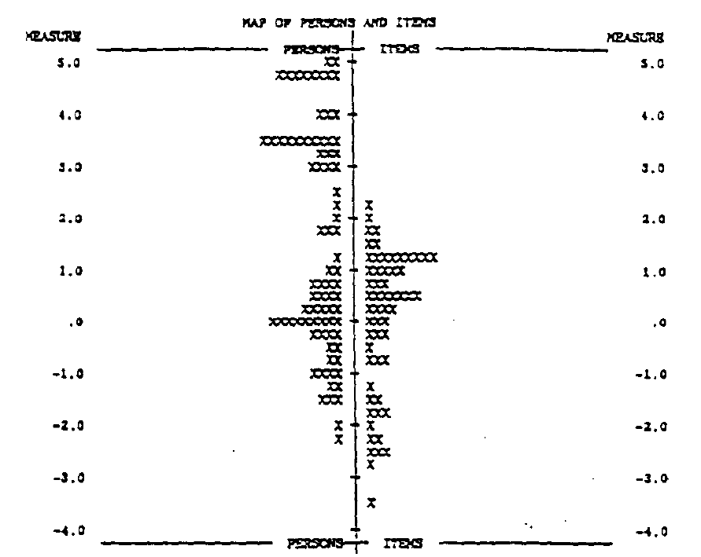
Figure 1. Logit Scale of Rasch Model Analysis of the Lollipop Test Scores

(Smith, 1991). Rather than treat this as a test equating exercise with common-item or common-person calibration, the scores were to be pooled in a single calibration while culture was treated as a demographic (like gender or race) in a bias detection approach. IPARM (Item and Person Analysis with the Rasch Model, I 992) offers new capabilities and graphic solutions to the task of quality control of person and item measures. For a fuller discussion of detecting item bias using the Rasch model, see Smith (1992).

RESULTS AND DISCUSSION
The Rasch Model was used to detect any deviation of scores that would detect cultural bias. Each question was examined for differential probabilities that a person of a given ability would get that item correct.
For the majority of items, bilingual performance was equivalent. Results indicated a bias in favor of Hispanic children on two type of items. First, in shape recognition Hispanic children did better than African American or white children when recognizing the “cross”. This was attributed to Hispanics being predominantly Catholic, and the children learning what the cross is at young age. Hispanics could also recognize a rectangle with greater ease than their counterparts.
On another stimulus card. the students were asked to identify the “smallest”, the “largest” and the “last”. Hispanic children did well at this task compared to white American children. An explanation is that Hispanic cultural in South America includes less television. The subsequent outdoor play supports the rules of games such as sequence.

285

One area of major disadvantage for Hispanic children was letter recognition. Specifically, these children had trouble with recognizing the letters C, E, D, and H. One possible explanation is that these students are not often read to at home. There are fewer books and magazines in the house. The children in Bolivia tend to stay home with a servant who is often illiterate. Formal education conducted primarily by the school.
It was clear that some items were influenced by culture and language to an extent that simple translation is not enough to create unbiased testing. The translation of a test into another language did not automatically make it a fair test. The test also needed to have cultural bias eliminated by discovering, editing or removing biased items.

REFERENCES

Arsenian, S. (1937). Bilingualism and mental development. New York: Columbia University.

Chew. A.L. (1989). The Lollipop Test: A Diagnostic Screening Test of School Readiness-Revised. Atlanta, GA: Humanics Limited.

Figueroa, R. A. (l 983). Test bias and Hispanic children. The Journal of Special Education, 17 (4), 431-440.

Mardell-Czudnowski, C. D. (1987). Screening kindergartners at an international school. School Psychology International, 8. 127-132.

Smith, M. R. (1991). IPARM: Item and person analysis with the Rasch Model. Chicago: Mesa Press.

Smith, M. R. (1992). Applications of Rasch Measurement. Chicago: Mesa Press.

286

